1. Complex variables transform
2. Instrumentation and measurements
3. Digital logic design
4. Object oriented programming
5. Electronics devices and circuits
6. Total credit hour:4
7. Total credit hours: 4
8. Total credit hours: 4
9. Total credit hours: 3
10. Total credit hours: 4

Total credit hours of above mention subject: 19

CGPA: previous 3.17

Semester 1 and 2 transcript is shown below:

CGP

1. CVT 4\*3.75=15
2. IAM 4\*3.75=15
3. DLD 4\*2=08
4. OOP 3\*2.5=7.5
5. EDC 4\*3.75=15

TOTAL CGP= 60.5

Total CGPA = CGP/Total credit hours of each subject add up

Total CGPA= 3.18

Semester 1 and 2 is 3.17 and 3rd semester is 3.18

Add them to get average CGPA=3.17+3.18

CGPA= 3.175

REMEMBER:

A=4

A-=3.75

B+=3.5

B-=3.75

B=3

C-=1.75

C+=2.5

D=1

ADDING TRANSCRIPT OF THE 1ST AND 2ND SEMESTER:

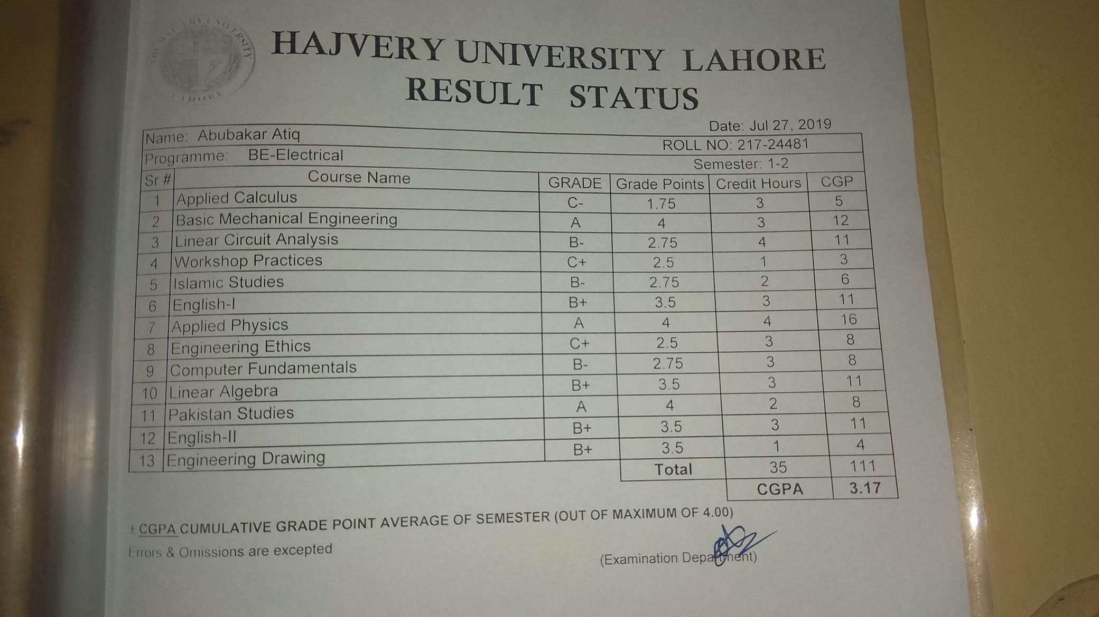

Transcript ;

